What to do today
IMPORTANT! Parent or Carer – Read this page with your child and check that you are happy with what they have to do and with any weblinks or use of the Internet required.

1. It’s reading time!
Read and enjoy the Hamilton Group Reader, The Race Across the River, by Ruth Merttens and Anne Holm Petersen.
- Do you think a race between lots of animals would be an exciting thing to have at a birthday party? Why?
- How would you control all those noisy, squabbling animals?

2. The Jade Emperor’s birthday: ideas
The Jade Emperor needs your help planning his perfect birthday party. What things do you suggest the Emperor has or does at his party?
- Games: hide and seek, pass the parcel. Food: cake, crisps. Decorations: balloons, fairy lights, etc.
- Record all your good ideas on the Party Planner.
- Use describing words where you can: yummy cake, colourful balloons.

3. The Jade Emperor’s birthday: writing sentences
Now, on The Jade Emperor’s Birthday Party, write down your suggestions in sentences. Follow the instructions on the sheet.

Now try this Fun-Time Extra
- Decorate the borders of your page with lots of ‘birthday party’ pictures.
Party Planner

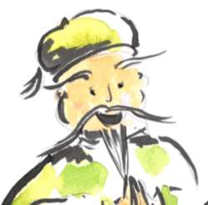

This is what I suggest the Jade Emperor has and does at his party.

Food | Drinks | Games | Decorations
The Jade Emperor’s Birthday

- Use and to join two of your ideas together in a single sentence: You can play a game of chase and have a massive chocolate cake.  - Remember to use capital letters to start your sentences and a full stop to end them.  - Challenge yourself! How many sentences can you write in your very best handwriting? | and

________________________________________________________________________________________________________________________________________________________________________________________________________________________________________________________________________________________________________________________________________________________________________________________________________________________________________________________________________________________________________________________________________
______________________________________________________________________________________
______________________________________________________________________________________

