[](http://www.google.co.uk/url?sa=i&rct=j&q=&esrc=s&frm=1&source=images&cd=&cad=rja&docid=JfG062VubuibnM&tbnid=E93l0zmrsm58yM:&ved=0CAUQjRw&url=http://www.beeskneesdance.com/the-full-season-knock-out-draw/pow/&ei=AKQ1UoSHEMextAaq_IDoBA&psig=AFQj)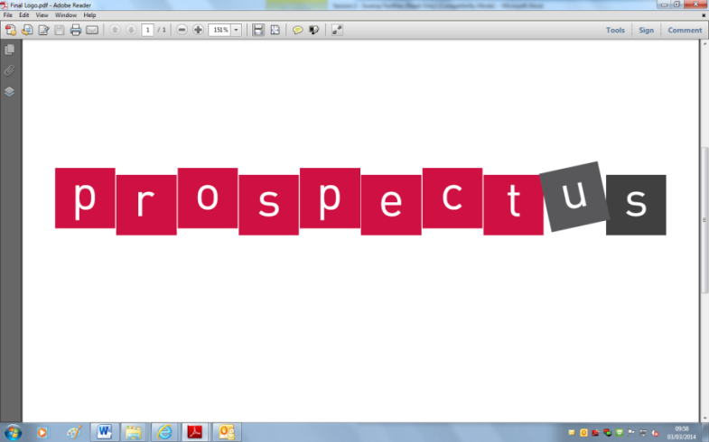

**This half term’s POWer Project is:**

**‘Materials’**

**HAND IN BY:**

***Choose projects to achieve your minimum 5 POWer Points.***

***By all means go over 5points!***

***Tick off what you have completed to achieve your points.***

**2 POWer Points:**

* Find some natural and man-made materials in your home.
* Go for a walk and collect some   
  natural materials.
* Make an instrument out of recycled materials.
* Look at different materials used to build your home and describe their properties e.g. Bricks are used for walls because they are hard.

**1 POWer Point:**

* Use <http://www.bbc.co.uk/schools/scienceclips/ages/7_8/characteristics_materials.shtml> to find out about materials.
* Write an information page about materials.
* Make toast and write about how the bread changes.

**2 POWer Points:**

* If it snows! Go outside and investigate ways of making the snow melt. What happens if you sprinkle salt on snow?
* Make ice cubes. Can you stop them from melting?
* Can you design something to keep your toast warm?

**3 POWer Points:**

* Can you make an evacuee costume   
  using old clothes and different   
  materials?
* Investigate heating and cooling (with a grown up). Can you melt chocolate and make a crispy cake? Can you freeze ice or juice to make a slushy drink or lollypop?
* Make a collage using different materials.
* Make a model using different   
  materials - take a photo and write what you did.