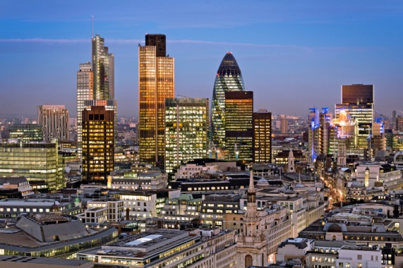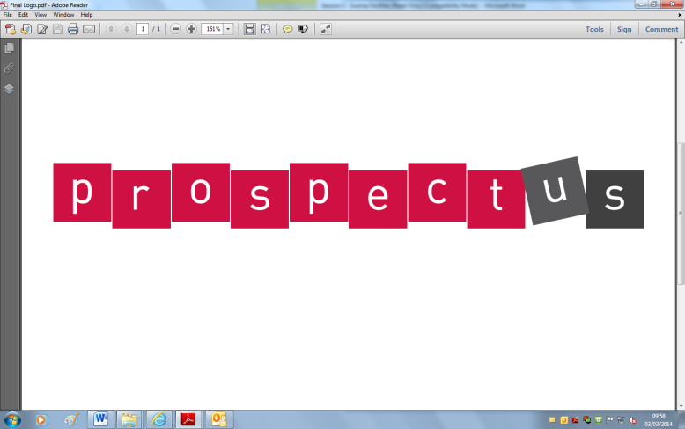[](http://www.google.co.uk/url?sa=i&rct=j&q=&esrc=s&frm=1&source=images&cd=&cad=rja&docid=JfG062VubuibnM&tbnid=E93l0zmrsm58yM:&ved=0CAUQjRw&url=http://www.beeskneesdance.com/the-full-season-knock-out-draw/pow/&ei=AKQ1UoSHEMextAaq_IDoBA&psig=AFQj)

**This half term’s POWer Project is:**

**‘A New London’**

**HAND IN BY:**

**Explore your mathematical skills:**

**Money**

Investigate the cheapest way for a family of 4 to visit your New London for a weekend

* How will you travel?
* Where will you go?
* Where will you stay?

***Choose projects to achieve your minimum***

***5 POWer Points.***

***By all means go over 5points!***

***Tick off what you have completed to achieve your points.***

**Extend your research skills:**

* Research some of the new buildings in London (e.g. The Gherkin)
* Research other key events in London.
* Research famous architects who have designed interesting buildings and structures.

**Explore your locality:**

How has your locality changed over time? What significant events have happened to change where you live?

*Create a scrapbook of photos, clippings, pictures, first-hand accounts from relatives.*

**Develop your creativity:**

* Create a design for housing/ buildings in New London
* Make a map
* Create a model
* Design a new sign/ LOGO
* Create a guide to your New London