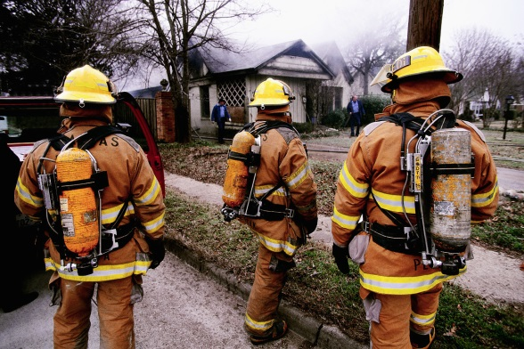[](http://www.google.co.uk/url?sa=i&rct=j&q=&esrc=s&frm=1&source=images&cd=&cad=rja&docid=JfG062VubuibnM&tbnid=E93l0zmrsm58yM:&ved=0CAUQjRw&url=http%3A%2F%2Fwww.beeskneesdance.com%2Fthe-full-season-knock-out-draw%2Fpow%2F&ei=AKQ1UoSHEMextAaq_IDoBA&psig=AFQj)

**Explore your skills:**

* Be a Baker...how can you bake safely?
* With an adult, carry out some baking. Take photos/ create a video of each stage showing how you measure and how you are safe.
* Write instructions.
* Create a safety manual

***Choose projects to achieve your minimum***

***5 POWer Points.***

***By all means go over 5points!***

***Tick off what you have completed to achieve your points.***

**This half term’s POWer Project is:**

**‘Fire Prevention and Protection’**

**HAND IN BY:**

**Extend your research skills:**

* Research how fires have caused problems in the environment around the world.
* [http://www.firefacts.org/#](http://www.firefacts.org/)
* <http://www.london-fire.gov.uk/gamesandactivities.asp>

**Develop your creativity:**

* Design a fire proof box to keep your most special items in.
* Make you fire proof ‘Memory box’
* Create a poster to explain fire safety at home
* Design a new fire-resistant uniform for the Fire Service.

**Explore your locality:**

* Where is your local Fire Service Station? Take photos, mark on a map of the local area.
* With your family, create a fire plan for your home.