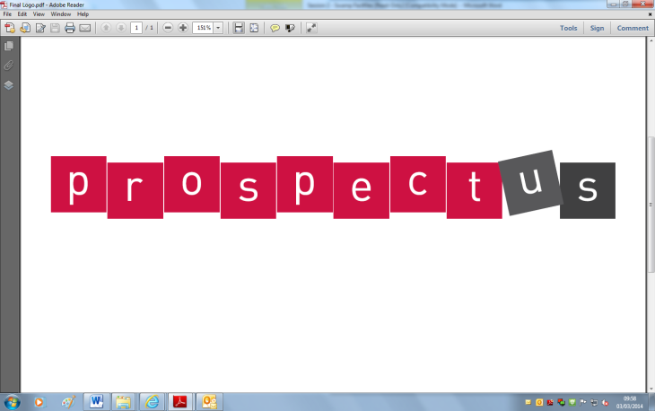[](http://www.google.co.uk/url?sa=i&rct=j&q=&esrc=s&frm=1&source=images&cd=&cad=rja&docid=JfG062VubuibnM&tbnid=E93l0zmrsm58yM:&ved=0CAUQjRw&url=http://www.beeskneesdance.com/the-full-season-knock-out-draw/pow/&ei=AKQ1UoSHEMextAaq_IDoBA&psig=AFQj)

**Explore your mathematical skills:**

**(2 points)**

* Create a chronological time-line of successful female children’s authors and illustrators throughout history.
* Create a ‘Top Trumps’ maths game about female children’s authors and illustrators

**Develop your creativity:**

**(3 points)**

* Make your own collage in the style of Lauren Child with a new character and story plot.
* Create a piece of artwork portrays an emotion linked to the story of ‘Tyrannosaurus Drip’.
* Write a new adventure story for ‘Mog’.

**This half term’s POWer Project is:**

**Wonder Women: Authors and Illustrators**



**Research:**

**(2 points)**

* Research other female children’s authors and illustrators throughout history. Create a mini photo fact-file to add to our class book.
* Interview family and friends about their favourite female children’s authors and illustrators. What were their favourite books? What made them special?

**Out and About:**

1. **points)**

* Visit a local library and look for books by female children’s authors and illustrators. Choose your favourite, read it and write a book review.
* Who are the local female authors and illustrators in your area? They can be past or present. Create a mini fact-file to add to class book.

***Choose projects to achieve your minimum***

***5 POWer Points.***

***By all means go over 5 points!***

***Tick off what you have completed to achieve your points.***