[](http://www.google.co.uk/url?sa=i&rct=j&q=&esrc=s&frm=1&source=images&cd=&cad=rja&docid=JfG062VubuibnM&tbnid=E93l0zmrsm58yM:&ved=0CAUQjRw&url=http://www.beeskneesdance.com/the-full-season-knock-out-draw/pow/&ei=AKQ1UoSHEMextAaq_IDoBA&psig=AFQj)

**Develop your creativity:**

**(3 points)**

* Create a gold medal made out of salt dough or clay.
* Paint a picture of your favourite Olympic Mascot.
* Write an acrostic poem using the letters OLYMPICS.
* Watch some of the cartoons involving Miraitowa and Someity– The Tokyo Mascots. Write your own story involving the two characters.
* Design or make a model of your own Olympic Stadium – remember to include a medal podium and Olympic flame!

**This half term’s POWer Project is:**

**Olympic Record Breakers!**

***Choose projects to achieve your minimum***

***5 POWer Points.***

***By all means go over 5points!***

***Tick off what you have completed to achieve your points.***

**Research:**

**(2 points)**

* Research a famous athlete from the past or the present day.
* Find out about a city that has hosted the Olympics in the past. What facilities are still there?
* Find out about the Ancient Greek Olympics – who would have competed? What sporting events were included?

**Explore your mathematical skills:**

**(2 points)**

* Your family want to visit the Olympics in Tokyo. How much would it cost to fly there and back.
* Calculate the distance your family would travel if they visited the Olympics in Tokyo. How long would it take?
* Design your own ‘symmetrical’ medal.

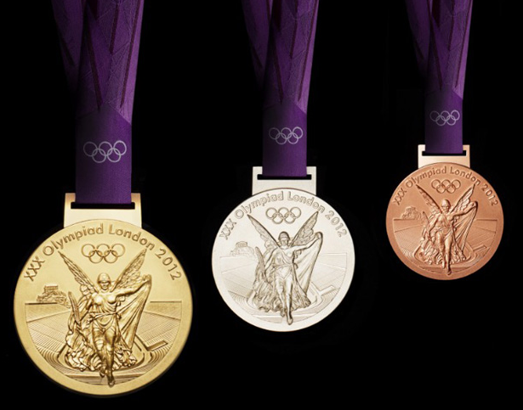

**Get Active!:**

**(3 points)**

* Have a go at an Olympic sport that you have never tried before. Take photographs or video clips.
* Have a go at trying to beat an Olympic Record. Measure the distances or times and try to beat them.