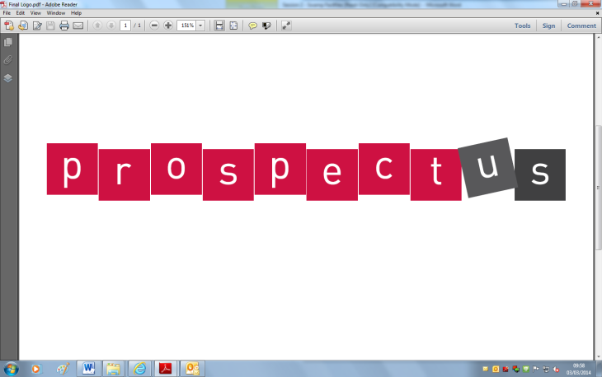[](http://www.google.co.uk/url?sa=i&rct=j&q=&esrc=s&frm=1&source=images&cd=&cad=rja&docid=JfG062VubuibnM&tbnid=E93l0zmrsm58yM:&ved=0CAUQjRw&url=http://www.beeskneesdance.com/the-full-season-knock-out-draw/pow/&ei=AKQ1UoSHEMextAaq_IDoBA&psig=AFQj)

**Explore your mathematical skills:**

**(2 points)**

* Collect at least 10 pictures of European flags that have at least one line of symmetry. Can you show the line of symmetry?
* Count to 10 in another European language.
* Find different totals in euros and cents. Find out how many euros there are in ten pounds.

**Develop your creativity:**

**(3 points)**

* Write your own adventure story based on Olivia travelling to a different place in Europe. What would she experience? What might she eat or see in these places?
* Pack a suitcase with 10 items that you would take on a holiday to a European destination.
* Create a simple model of a European landmark using LEGO or other modelling materials.

**This half term’s POWer Project is:**

**A Journey through Europe: Holidays!**

**Research:**

**(2 points)**

* Research a famous city or country in Europe (it may be one that you have visited or one that somebody in your class comes from).
* Research the different flags of European countries. What colours or patterns are the most or least common? What is the most unusual European flag? Match flags to different countries on a map.
* Research the different languages in Europe. Make a poster with ‘hello’ written in 10 different languages.

**Out and About:**

**(3 points)**

* Visit a local airport with your friends and family. What different European destinations could you fly to? How long are the flights to different cities? Where would you like to fly to?
* Visit a travel agent and pick up some different brochures for various types of European holiday e.g. summer sun, city breaks, skiing.

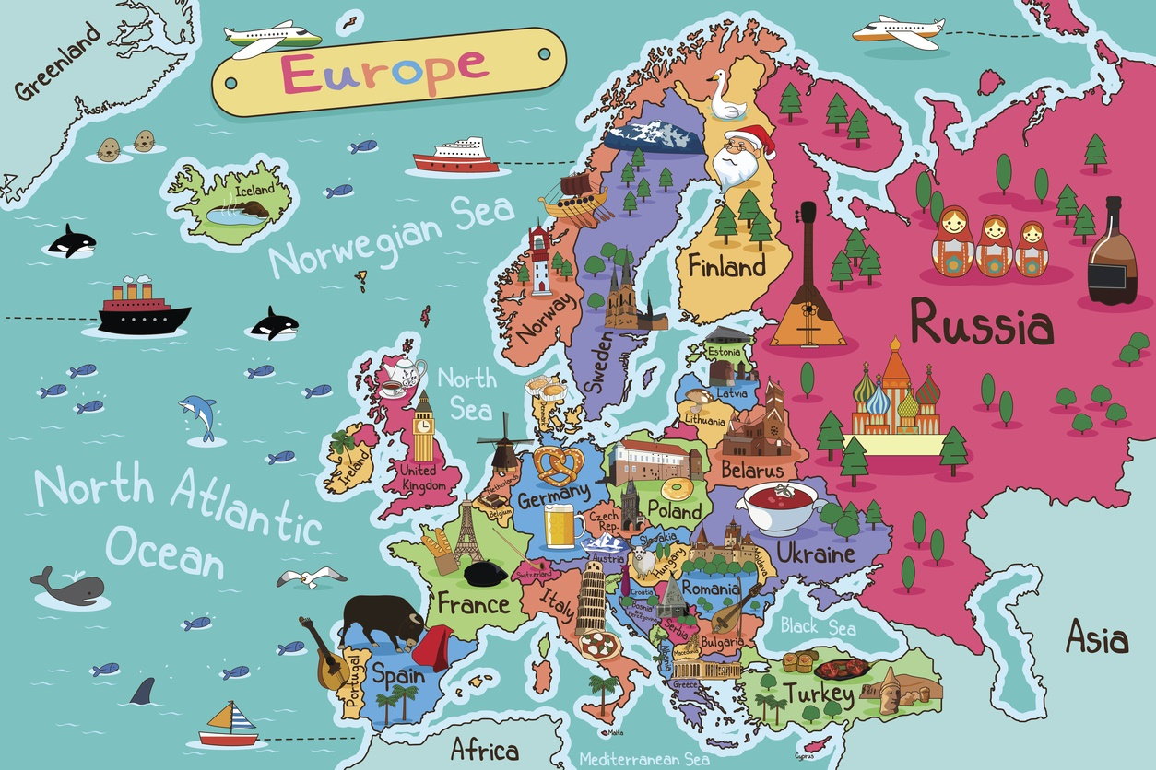

***Choose projects to achieve your minimum***

***5 POWer Points.***

***By all means go over 5 points!***

***Tick off what you have completed to achieve your points.***