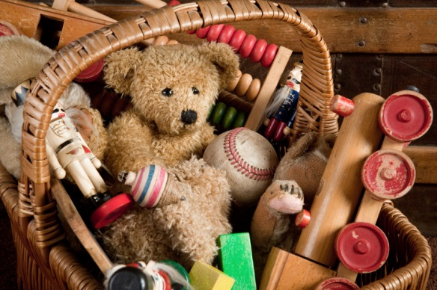**[](http://www.google.co.uk/url?sa=i&rct=j&q=&esrc=s&frm=1&source=images&cd=&cad=rja&docid=JfG062VubuibnM&tbnid=E93l0zmrsm58yM:&ved=0CAUQjRw&url=http://www.beeskneesdance.com/the-full-season-knock-out-draw/pow/&ei=AKQ1UoSHEMextAaq_IDoBA&psig=AFQj)**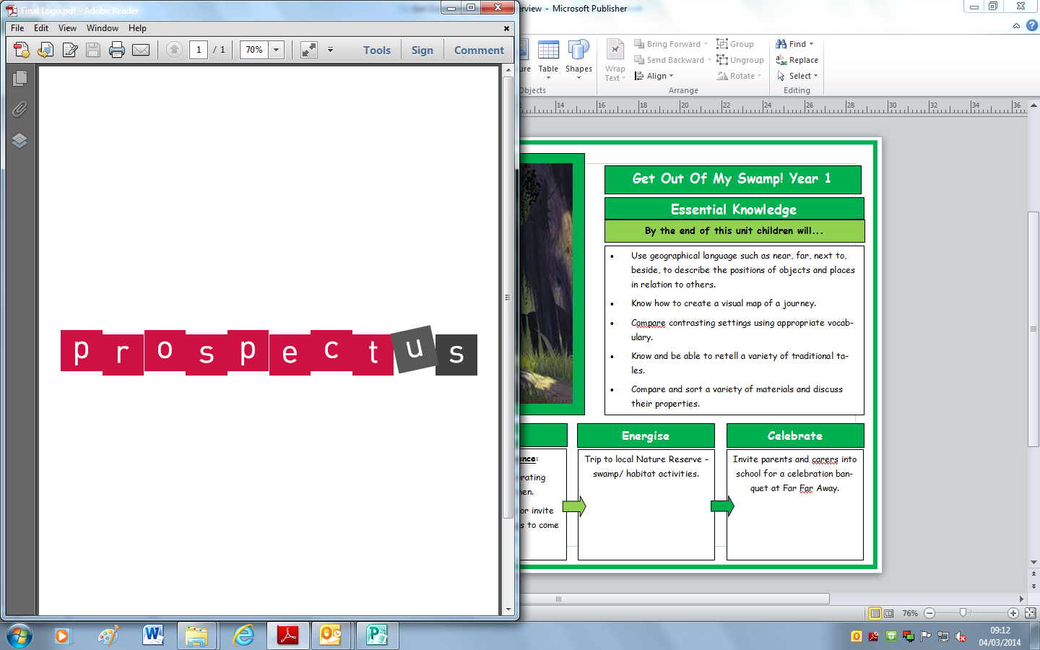

**This half term’s POWer Project is:**

**‘Toys from the future’**

**HAND IN BY:**

***Choose projects to achieve your minimum 5 POWer Points.***

***By all means go over 5points!***

***Tick off what you have completed to achieve your points.***

**3 POWer Points:**

* Can you design and make a toy out of recycled materials? (Plenty of ideas can be found online).
* What toys do children in other countries play with? Choose a country and compare their toys to your toys.
* Can you write a set of instructions explaining how to play with your favourite toy? Don’t forget to include photographs or drawings!

**2 POWer Points:**

* Imagine your toys came to life at night. What might happen? Where would they be?
* Can you write a rhyming poem about a toy?
* Can you build a model out of Lego and describe how you did it?

**1 POWer Point:**

* Choose some of your favourite toys, can you order them from smallest to biggest? From heaviest to lightest?
* Go to the library and see if you can find any stories about toys. Which is your favourite?
* Can you think of a toy for every letter of the alphabet?

**2 POWer Points:**

* Can you design a toy that children might play with in the future? What would it be made of? What would it do?
* Can you design a poster to advertise a toy?
* Look at the toys in your house. What are they made of? Can you create a pictogram to show the different materials you found?