What to do today
IMPORTANT! Parent or Carer – Read this page with your child and check that you are happy with what they have to do and with any weblinks or use of the Internet required.

1. It’s poem time!
Re-read There are Gribbles and Next Door and It’s Behind You! Then read a new poem by Paul Cookson, The Football Field Foul Fiend.
- Which is the most fun to say out loud? Say why it is the best to read out.

2. Looking at alliteration
Re-read The Football Field Foul Fiend.
- Introduce the idea of alliteration, using Looking for Alliteration and following the instructions.

3. Let’s get ready to write
Decide which monster poem of the four you have read you like the most.
- On My Best Monster Poem write out the title of the poem.
- Now write a series of correctly punctuated sentences explaining why you thought it was the best.

Now try this Fun-Time Extra
- Try and learn some of the lines from your favourite poem.
- Send a recording of you saying lines from your poem to a relative.

The Football Field Foul Fiend

Fifty foot of fearful fur  Fiendish feral fungus fangs  Fast ferocious freaky fins  The football field foul fiend  Fiery furnace furious features  Frightening frightful phantom face  Filthy fouling fearsome feet  The football field foul fiend | 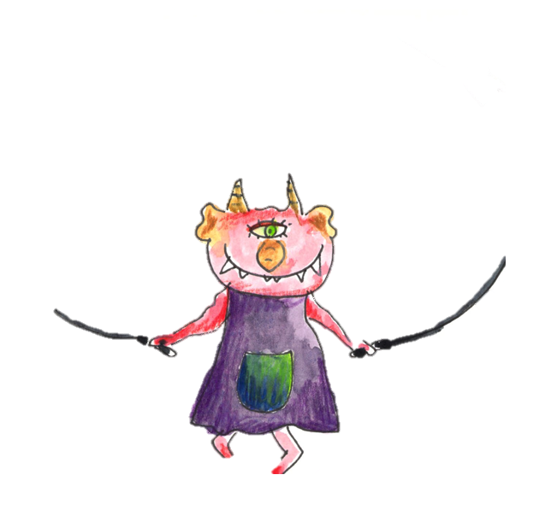

Paul Cookson

It’s Behind You! Monster Poems
by Paul Cookson and David Harmer

Looking for Alliteration

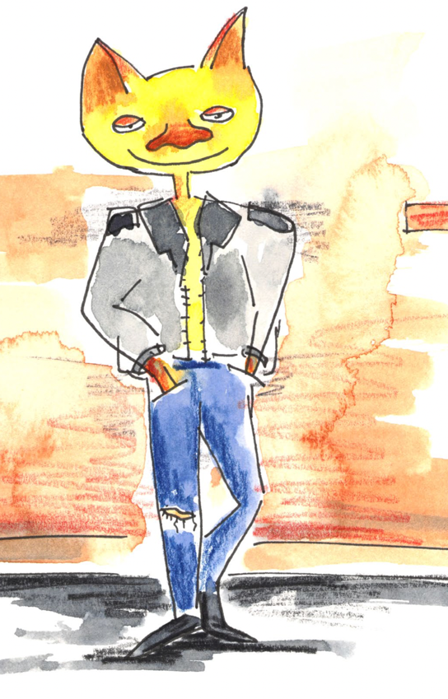

Re-read The Football Field Foul Fiend.

- What sound do most of the words in the poem begin with? (Football, foul, fiend, etc.) Introduce the idea of alliteration.

- Can you think of other words that begin with f that would alliterate with the poem’s words? Fast, figure, fun, fool, etc.

- Which word in the poem alliterates with the others but does not use the letter f to create the initial sound? Phantom.

- Do you know any other words that use the letters ph to make an f sound? (photograph, phonics, photocopy, Phillip, apostrophe)

My Best Monster Poem

Give 3 different reasons for your choice. Use the conjunctions because, since and as to introduce your ideas. I like the poem as it...

Use qualifying adverbs such as really, especially and very in your sentences. I really enjoyed the poem because it is very...
___________________________________________________

