What to do today
IMPORTANT! Parent or Carer – Read this page with your child and check that you are happy with what they have to do and with any weblinks or use of the Internet required.

1. It’s poem time!
Read and shiver at enjoy the monster poem, It’s Behind You! by David Harmer.
- Would you have been able to stop yourself turning round?
- What would you have done to save the poor person in the poem?

2. Exclamation marks and emphasis
Look at It’s Behind You!
- Follow the instructions on Looking at the Poem, and highlight some of the punctuation.
- Read the poem again, using the exclamation marks and capital letters as a guide to where to really stress lines and/or words.

3. Let’s get ready to write
What do you think the monster in the poem would actually have looked like?
- Draw your idea of the monster on Behind You!
- Describe your monster using full, accurately punctuated sentences.
- Include two exclamation marks and two capitalised words for emphasis in your writing. A really ENORMOUS pair of fangs!

Now try this Fun-Time Extra
- Think about a time you had a jump or a shock. Draw and write about what happened on It Made Me Jump!

It’s Behind You!

I don’t want to scare you
But just behind you
Is a ........................

No! Don’t look!
Just act calmly
As if it wasn’t there.

Like I said
Can you hear me if I whisper?
Just behind you
Is a ..................

NO! DON’T LOOK!
Just keep on reading
Don’t turn round, believe me
It isn’t worth it.

If you could see
What I can see standing there
You'd understand.

It’s probably one
Of the harmless sort
Although with that mouth
Not to mention those teeth
And all the blood dripping down its chin
I wouldn’t like to say.

DON’T TURN ROUND!
Listen
It’s trying to speak
I think it wants to be friends.

Oh, I see, it doesn’t!
Never mind
You’d better leave just in case
I expect you’ll escape
If you don’t turn round.

Oh what a shame.
I really did think
You’d make it to the door.
Hard luck
I expect it eats all its friends.

David Harmer

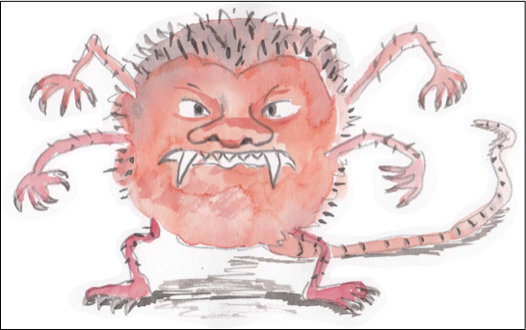 | It’s Behind You! Monster Poems  by Paul Cookson and David Harmer,  MacMillan Children’s Books, 2010
Looking at the Poem…

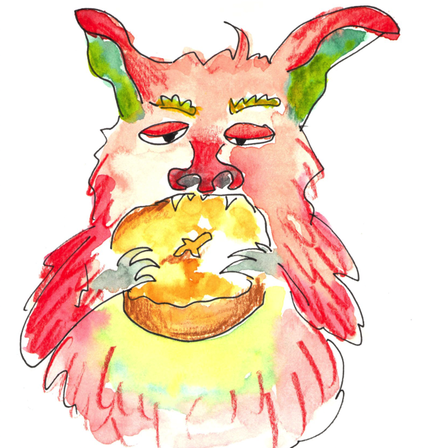

- What is the punctuation mark called at the end of the title?

- Highlight all the exclamation marks in the poem. How many are there?

- Why are they there?

- Highlight all the words in capital letters. Why has the writer done this with these words?

- Read the poem again. This time, use the exclamation marks and capital letters as a guide to where to really stress lines and/or words.

Ask someone to listen to you read.
Can they hear how good it sounds?

Looking at the Poem…With notes for adults

- What is the punctuation mark called at the end of the title? An exclamation mark.

- Highlight all the exclamation marks in the poem. How many are there? 7 including the one at the end of the title.

- Why are they there? To show these lines are being said forcefully and with emphasis.

- Highlight all the words in capital letters. Why has the writer done this with these words? Again, to emphasise or stress those words.

- Read the poem again. This time, use the exclamation marks and capital letters as a guide to where to really stress lines and/or words.

Ask someone to listen to you read.
Can they hear how good it sounds?

Behind You!

It Made Me Jump!

