What to do today
IMPORTANT! Parent or Carer – Read this page with your child and check that you are happy with what they have to do and with any weblinks or use of the Internet required.

1. It’s reading time!
Re-listen to The Paper Bag Princess at https://www.youtube.com/watch?v=hIPrb-sA6Uo&t=168s or watch again https://www.youtube.com/watch?v=P0lNFZtpq7A
- What different settings are there in the story?
- How would you describe the land through which the Princess travels? How would you describe the Dragon’s cave?

2. Adverbs for description
Watch the PowerPoint: Noun Phrases 2 and listen to the teaching. Then read carefully the information on Adverbs to reinforce this.
- Complete the exercise on Using Adverbs.
- Remember to choose ‘an’ or ‘a’ as appropriate.

3. Let’s get ready to write
Look at the different categories on the Paper Bag Word Banks.
- Moving from left to right, pick one word from each box to make a description, e.g. A lot of really handsome dragons.
- Add more information to create a sentence. Write this on Paper Bag Sentences.

Now try these Fun-Time Extras
- Cut out the Pictures of Prince Ronald, Princess Elizabeth and the Dragon or do your own drawings of them.
- Glue the pictures to lolly sticks or strips of thick cardboard.
- Use your figures to retell the story of The Paper Bag Princess and/or make up new adventures for the trio.

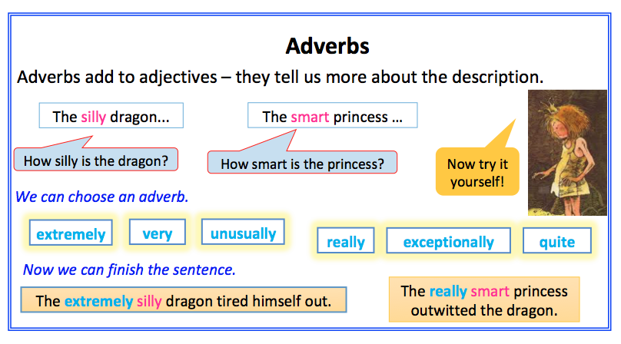

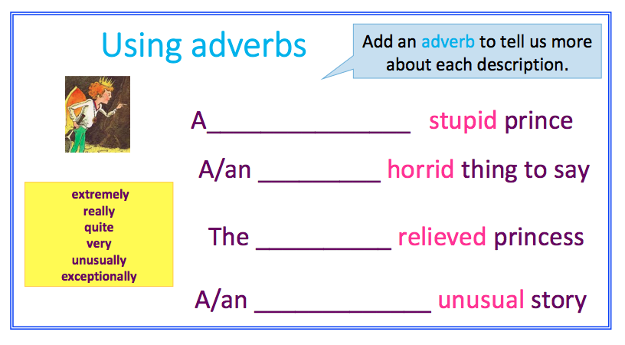
Paper Bag Word Banks

- Moving from left to right, pick one word from each box to make a description, e.g. A lot of really handsome dragons…  - Write your description on Paper Bag Sentences  - Add some more information to make a sentence. E.g. A lot of really handsome dragons from all over the mountains flew past us.  - Repeat this to generate a new description and a new sentence. | 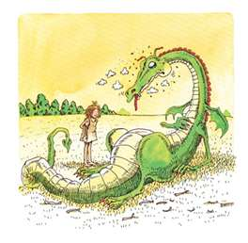

Determiners | Adverbs | Adjectives | Nouns
A An The  Those My His  Her This That  Some A lot of | very absolutely  extremely awfully  really dreadfully  especially hugely  unusually frequently  quite usually | scary pretty  brave dangerous  small handsome  sharp smoky  green happy  tall sad | dragon prince  princess castle  forest sword  rock flame crown  paper bag prison  Remember - you can add an -s or -es to turn each noun into a plural (more than one of them), e.g. dragons, princesses.

Paper Bag Sentences

How many sentences can you write? Can you write your sentences without repeating any words?

________________________________________________________________________________________
________________________________________________________________________________________
________________________________________________________________________________________
________________________________________________________________________________________
________________________________________________________________________________________
________________________________________________________________________________________
________________________________________________________________________________________
________________________________________________________________________________________
________________________________________________________________________________________
________________________________________________________________________________________
________________________________________________________________________________________
________________________________________________________________________________________
_______________________________________________________________________________________

Pictures of Prince Ronald, Princess Elizabeth and the Dragon

