What to do today
IMPORTANT! Parent or Carer – Read this page with your child and check that you are happy with what they have to do and with any weblinks or use of the Internet required.

1. It’s reading time!
Listen to the author, Robert Munsch, read his story The Paper Bag Princess on YouTube at https://www.youtube.com/watch?v=hIPrb-sA6Uo&t=168s . And/or watch a version with the illustrations and text https://www.youtube.com/watch?v=P0lNFZtpq7A .

2. Nouns and adjectives
If possible, watch the PowerPoint: Noun Phrases 1. Listen to the teaching. Then read carefully through the two information sheets, Nouns / Adjectives.
- Read aloud all the words listed on Identifying Nouns. Write the nouns. Check with the Answers. Score 1 point for every word you got right.
- Now read the two sentences on Identifying Adjectives. Write all the adjectives in the sentences. Check with the Answers and again score a point for each one correct. How many points did you get altogether?

4. Let’s get ready to write
What are the names of the three characters in The Paper Bag Princess?
- Pick one, draw them and write their name carefully at the top of Characters. Don’t forget to use an initial capital letter.
- Write correctly punctuated sentences describing what they look like.
- Do the same to say what kind of personality they have.
- Use exciting and interesting adjectives to describe your nouns. Challenge yourself to add adverbs as well if you want.
- If you have time, do the same thing for another of the characters.

Now try this Fun-Time Extra
- Draw your own Castle and add captions and labels to your drawing,

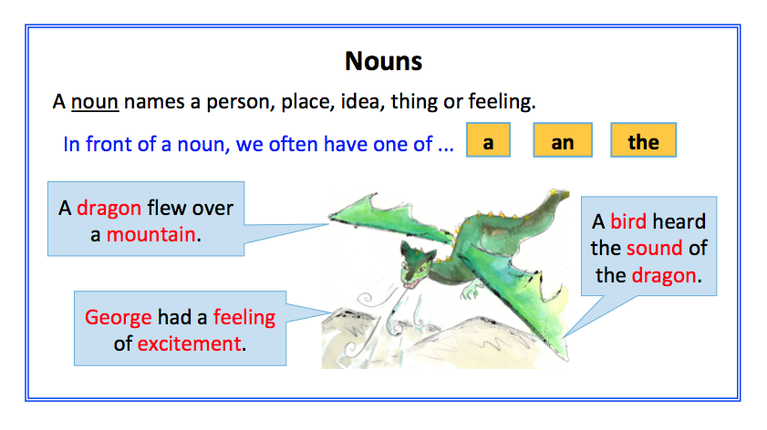

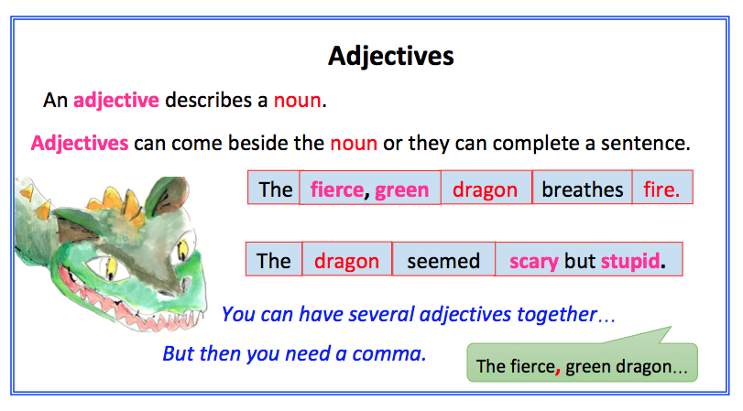

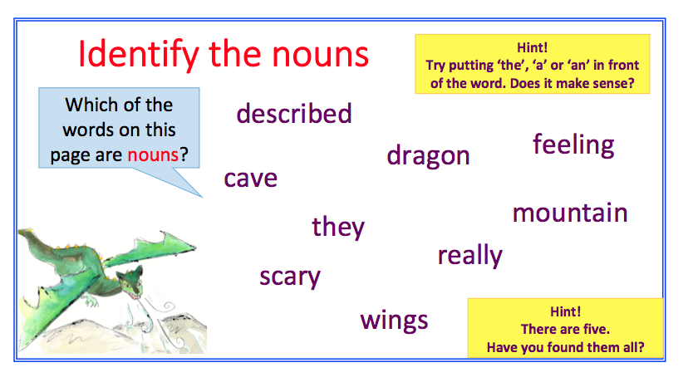

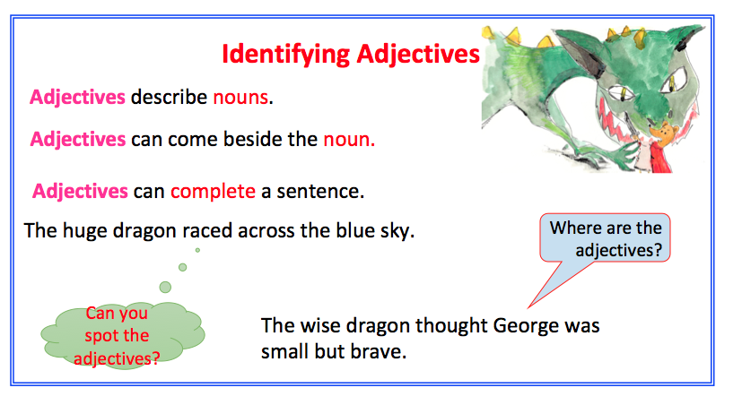
Identify the Nouns

Identify the adjectives

Characters

________________________________________________

Castle

Answers

Identifying Nouns

The nouns are:

dragon
cave
mountain
wings
feeling

Identifying Adjectives

The adjectives are:

Sentence 1 – huge and blue
Sentence 2 – wise, small and brave

