What to do today
IMPORTANT! Parent or Carer – Read this page with your child and check that you are happy with what they have to do and with any weblinks or use of the Internet required.

1. Looking at noun phrases
If possible, open the PowerPoint – Noun Phrases_1.
- Read through it, revising nouns, adjectives and adverbs.
- See if you can tell someone what a noun, an adjective and an adverb are. If you get muddled, re-read the slides until you are clear.
- If you cannot open a PowerPoint, look at Revise Noun Phrases.

2. Locating nouns, adjectives and adverbs.
Read the story of The Girl Who Cried... Monster!
- Use one colour to highlight 10 of the nouns in the story.
- Use a second colour to highlight 10 of the adjectives.
- Use a third colour to highlight 5 of the adverbs.

3. Descriptive writing
Now read and enjoy the story, In Every Corner.
- Pick one of the monsters you really like the look of.
- Copy it onto Monster!
- Write a descriptive paragraph about your monster using adverbs and adjectives to describe nouns (...extremely long, greasy hair; ...very sharp white teeth).
- Do the same things for another monster if you have time.

Now try this Fun-Time Extra
- Think of the best monster hiding places in your house. On The Best Monster Hiding Places in MY House, list them, describe each and say why they would be so good.

Revise Noun Phrases
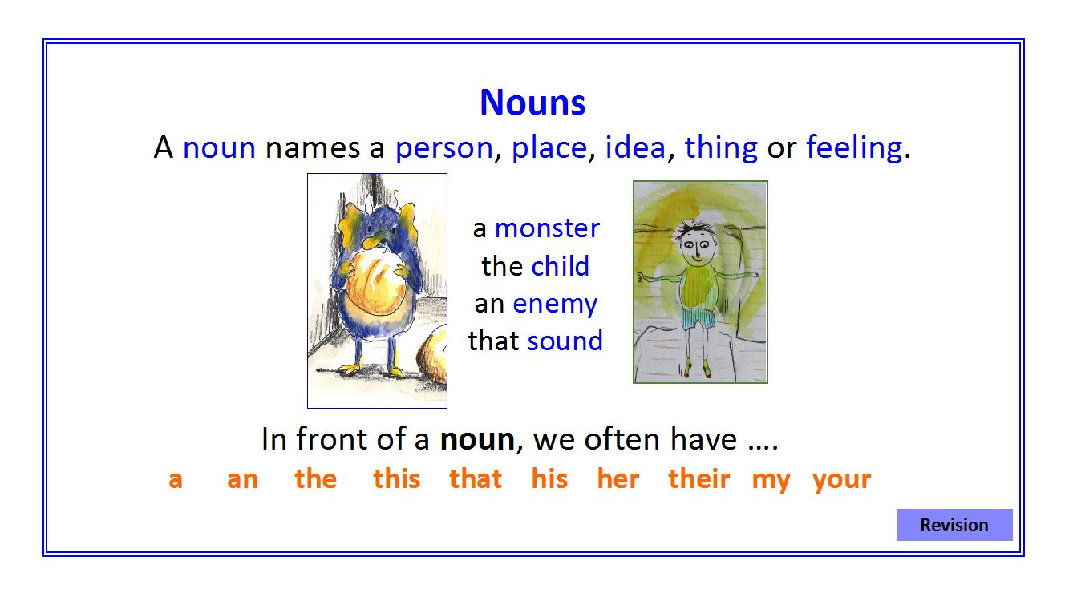
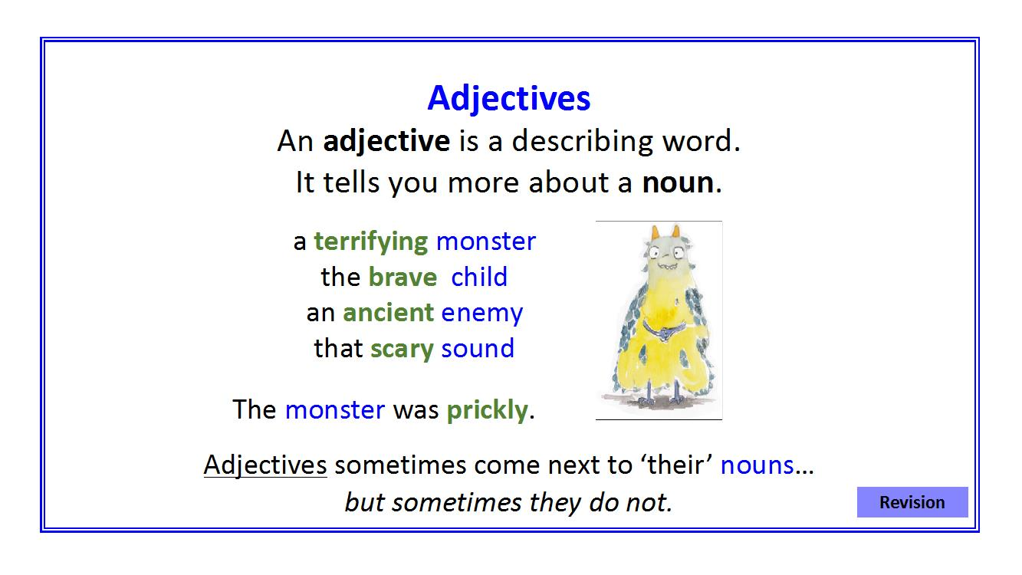
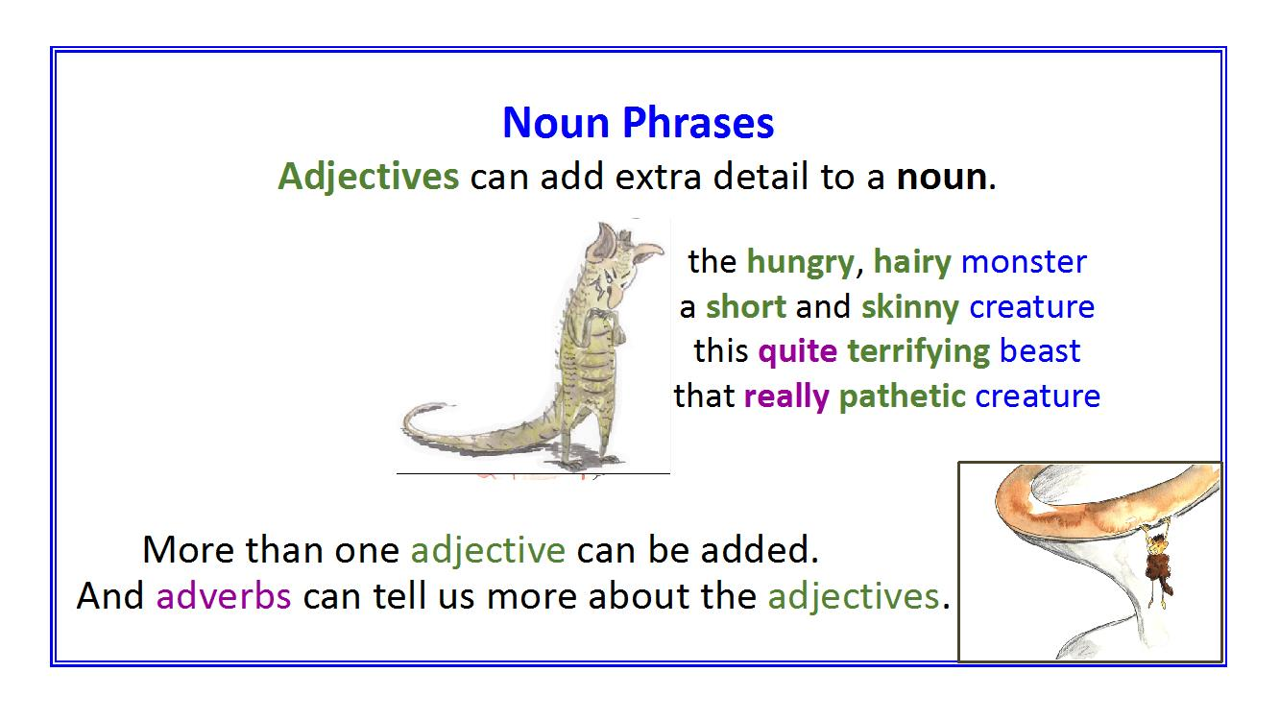
The Girl Who Cried... Monster!

At their school, all the children had been told to look out for really horrible, hairy monsters. Hansini from Year 2 had been given the job of keeping watch by the very tall school gates. She was really excited and she looked along the busy road. She looked amongst the green trees. She looked up into the grey sky and she looked out to the distant hills.

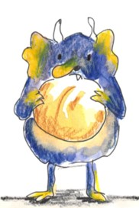 | But it was an extremely cold, windy day and Hansini began to feel quite bored and lonely. She decided to pretend that she had seen a monster. She cried out, ‘Help! Help! A huge, horrible and hairy monster!’ The children and the teachers came running, but of course there was no scary monster there. The Head Teacher told Hansini off and she promised not to make up any more stories. Everyone went back to their lessons.
A bit later it began to rain and Hansini felt even more lonely and sad. So she cried out again, ‘Help! Help! A quite slimy and ugly monster!’ All the children and teachers rushed to see what has happening, but once again there was no monster there. Hansini’s kind teacher, Mrs Woollard, was upset and cross. ‘You must not make up silly stories about terrible monsters, Hansini!’ she said.

Hansini promised and went back to watching. Suddenly a really big, bald, green monster appeared by her side! It had bright, red eyes and a round, yellow nose. Its chin was very hairy. ‘HELP! HELP! A hideous, frightening monster!’ screamed Hansini in a loud and anxious voice.

In the school everyone heard her shouts but just thought, ‘Oh, it’s only Hansini, making things up again.’ The teachers carried on teaching and the children carried on learning. And that was the end of poor Hansini. At least the monster had a nice, full tummy!

Monster!
The Best Monster Hiding Places in MY House

The Girl Who Cried... Monster! ANSWERS

At their school, all the children had been told to look out for really horrible, hairy monsters. Hansini from Year 2 had been given the job of keeping watch by the very tall school gates. She was really excited and she looked along the busy road. She looked amongst the green trees. She looked up into the grey sky and she looked out to the distant hills.

But it was an extremely cold, windy day and Hansini began to feel quite bored and lonely. She decided to pretend that she had seen a monster. She cried out, ‘Help! Help! A huge, horrible and hairy monster!’ The children and the teachers came running, but of course there was no scary monster there. The Head Teacher told Hansini off and she promised not to make up any more stories. Everyone went back to their lessons.

A bit later it began to rain and Hansini felt even more lonely and sad. So she cried out again, ‘Help! Help! A quite slimy and ugly monster!’ All the children and teachers rushed to see what has happening, but once again there was no monster there. Hansini’s kind teacher, Mrs Woollard, was upset and cross. ‘You must not make up silly stories about terrible monsters, Hansini!’ she said.

Hansini promised and went back to watching. Suddenly a really big, bald, green monster appeared by her side! It had bright, red eyes and a round, yellow nose. Its chin was very hairy. ‘HELP! HELP! A hideous, frightening monster!’ screamed Hansini in a loud and anxious voice.

In the school everyone heard her shouts but just thought, ‘Oh, it’s only Hansini, making things up again.’ The teachers carried on teaching and the children carried on learning. And that was the end of poor Hansini. At least the monster had a nice, full tummy!

