What to do today
IMPORTANT! Parent or Carer – Read this page with your child and check that you are happy with what they have to do and with any weblinks or use of the Internet required.

1. Story time
Re-read the story, Wild Pets.

2. Using apostrophes to show possession
Find the following phrases in the story and carefully copy them down onto a piece of paper: Bella’s cat and Sunil’s dog.
- Can you name the punctuation mark used in each one?
- Can you say why it is there?
- Together with a grown-up, read the information on Using an apostrophe to show possession.
- Complete the exercises on Possessive Apostrophes.

3. Writing time
Today you are going to write out the wild pet story that you planned yesterday.
- Begin by make your own Mini Story Book ready for writing in.
- Continue by using your planner from yesterday and the instructions on Writing a story below.

Now try this Fun-Time Extra
- Decorate your story and read it aloud to your family.

Using an apostrophe to show possession

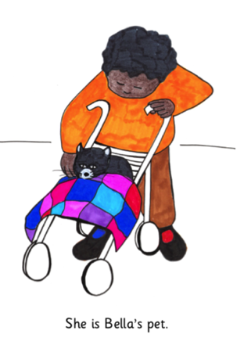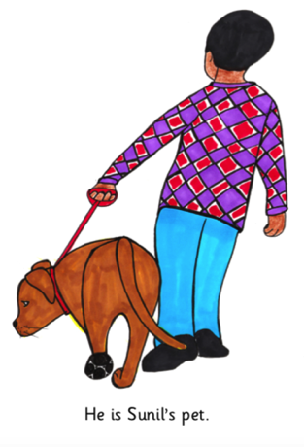

‘Possession’ means belonging to someone or something.
When we have or own something, we say we possess it.

We can show that someone or something possesses something by adding an apostrophe (’) and an s to their name.

The cat that belongs to Bella is Bella’s cat

Sunil’s dog is the dog that Sunil owns.

The blanket that the cat sleeps under is the cat’s blanket.

The dog’s collar is the collar that the dog wears.

The pattern on the blanket is the blanket’s pattern.

When we are showing possession, the apostrophe and the s always come after the person or thing’s name.

Matt’s fish CORRECT
Mat’ts fish NOT CORRECT
Matts’ fish NOT CORRECT

The apostrophe always goes high up between the name and the s, not down on the line like a comma.

Matt’s fish CORRECT
Matt,s fish NOT CORRECT

Remember! Words that are just plurals (when we have more than one of something), like dogs, cats, blankets or collars, end in an s but do not need an apostrophe because the sentence is not about possession, e.g. Three dogs ran down the street.

Possessive Apostrophes

1. Highlight the possessive apostrophe +s in these sentences:

Mia’s rabbit is white and gentle.
Mia sits calmly outside the rabbit’s hutch.
Mia picks the rabbit’s food from her own garden.

2. Add a possessive apostrophe in the right place in these sentences:

Sunils dog runs through the park at night with the other dogs.
Night time is when Matts fish turn into wild sharks.
Everybody loves the childrens pets.

3. Mark these sentences right or wrong depending on whether the apostrophe + s has been used correctly or not.

Jim’s puppy is three months old. ___________________________________
It is walk time for Ruths dogs. _____________________________________
Alic’es cat is black and white. ______________________________________
Tom,s hamster is ENORMOUS! ____________________________________
It is bathtime for Eva’s terrapin, Horace. _____________________________

With the ones that you have marked WRONG, rewrite the apostrophe word so that it is correct.

Now check with the Answers page to see how you did!

Writing a story

- Make the mini-book outlined in the instructions below

- Start to turn the ideas on your planner into full sentences in your mini book.
Once there was a kind and cheerful boy called Oli. He had a tiny golden hamster called Pog who liked to...

- When you get to the part about the pet going wild at night, go into as much detail as you can!
Pog pushed open his cage’s door and scrambled out onto the table. All around he could hear the tiny squeaks of other hamsters breaking out of their cages too.

- Remember to include possessive apostrophes where you need to (cage’s door).

- Make sure all your sentences start with capital letters and end with full stops.

Mini Story Book Making Instructions

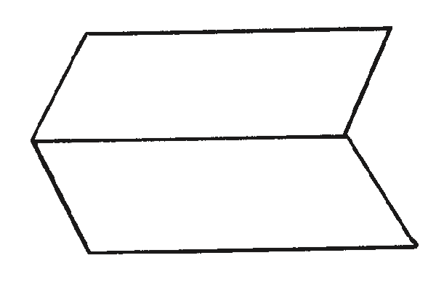
- Fold a sheet of paper in half lengthways and then unfold it.

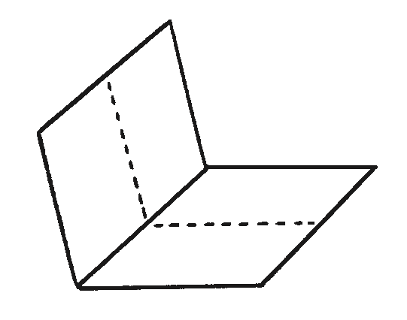
- Fold the same sheet of paper in half widthways and leave it folded.

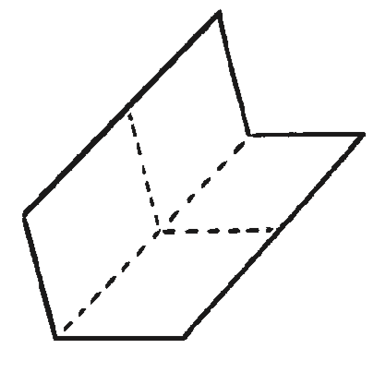
- Fold it in half again in the same direction and then unfold the last fold.

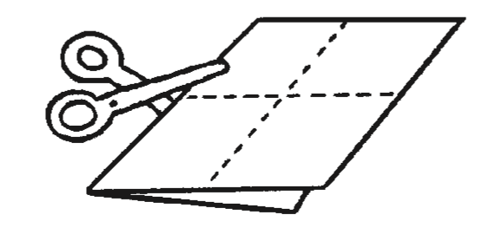
- Cut along the centre crease until you reach the middle of the piece of paper.

- Unfold the paper completely. There should be a slit through the middle of the paper. Fold the paper in half lengthways again and then push the two ends inwards towards each other to create a star shape with four arms.
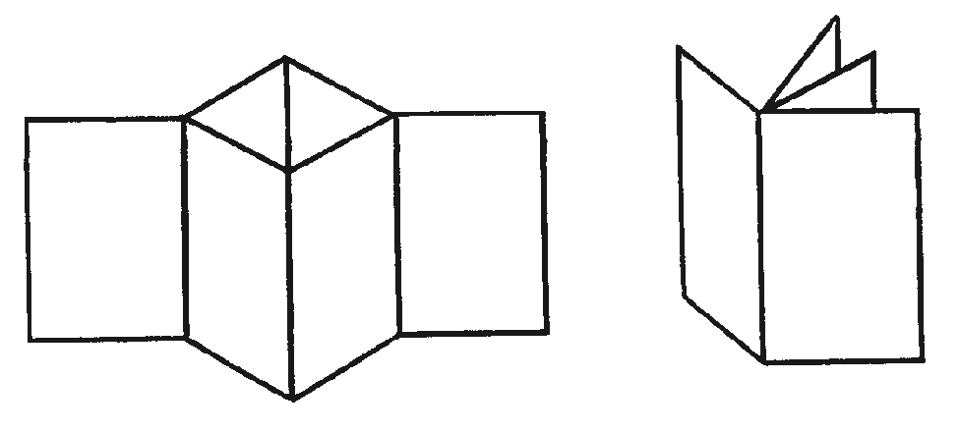

- The four arms are the pages of the book. Fold all of the arms around to face the same direction and the book is complete.

My Possessive Apostrophes – Answers

1. Highlight the possessive apostrophe +s in these sentences:

Mia’s rabbit is white and gentle.
Mia sits calmly outside the rabbit’s hutch.
Mia picks the rabbit’s food from her own garden.

2. Add a possessive apostrophe in the right place in these sentences:

Sunil’s dog runs through the park at night with the other dogs.
Nighttime is when Matt’s fish turn into wild sharks.
Everybody loves the children’s pets.

3. Mark these sentences right or wrong depending on whether the apostrophe + s has been used correctly or not.

Jim’s puppy is three months old. Right!
It is walk time for Ruths dogs. Wrong! Ruth’s
Alic’es cat is black and white. Wrong! Alice’s
Tom,s hamster is ENORMOUS! Wrong! Tom’s
It is bathtime for Eva’s terrapin, Horace. Right!

