What to do
IMPORTANT Parent or Carer –
Please check that you are happy with any weblinks or use of the internet.

1. Counting practice
  - Take turns to count. This is harder than you think!
  - One person says ‘one’.
  - The second person says ‘two’.
  - The first person says ‘three’’.
  - Continue like this, taking turns, until you reach 20.
  - Repeat but this time speed up!
  - Repeat but this time the other person starts – so you are saying different numbers.
  - Repeat but count backwards from 20 to blast-off!

Extension
- Try this with three people – that’s really hard, especially if you go fast!

2. Working together

- How many in a shoe?
- You need small objects, e.g. Lego™ bricks, buttons, conkers, shells, very small toys, vehicles, figures or animals – fat felt-tips and paper.
- Complete the activity How many in a shoe? below.

Try these Fun-Time Extras

- How many things can you fit in a tablespoon? Try using really small items. What is the most you can manage?
- Watch how many things you can get in a matchbox (or any small box) https://www.youtube.com/watch?v=cKB0aHue42I

How many in a shoe?

You need small objects, e.g. Lego™ bricks, buttons, conkers, shells, very small toys, vehicles, figures or animals – fat felt-tips and paper

What to do

- Choose a child’s shoe or slipper.
- Choose some very small toys, bricks, shells or other counting objects.
- Discuss how many we think will fit in the shoe. We shall fill it, but not over-fill it. So, it won’t be piled up, just nicely full.  - Once the shoe is full, look at it together.  - Each of you must estimate how many things are in the shoe. | 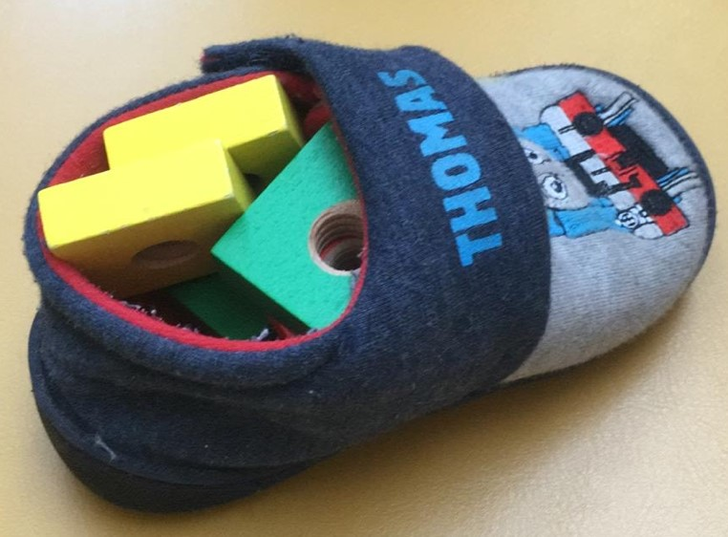
- Write down your guesses next to your names.
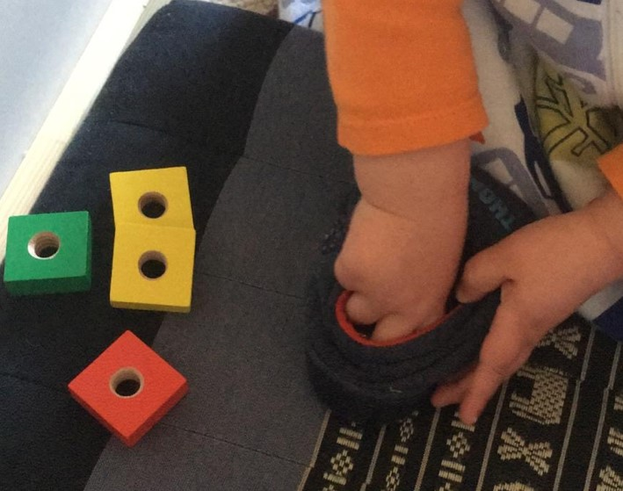 | - Now you take out the things one by one.  - Count them as you do this.  - How many are there?  - How close were your guesses?  - Who was closest?  - Write the number in figures.
- Repeat this as many times as you can using different items to fill the shoe. You should get better at estimating!

