What to do
Writing
IMPORTANT Parent or Carer –
Please check that you are happy with any weblinks or use of the internet.

Our focus today is writing.

1. Discuss the type of information in a book

Read or re-read Spring for the Birds. This book has lots of information. What things can we find out by reading this book? Types of bird, where they build their nests, what they feed their young, etc.

2. Write captions.

- Explain that in information books, the pictures sometimes have captions: special sentences which explain what the pictures are showing. For example, page two’s caption could be ‘The blackbird sings to talk to other birds.’
  - Explain that Spring for the Birds does not have any captions.
  - Look at the pictures from the book on Captions below and work together to say some captions which could go with the pictures to explain what they are showing.
  - Choose one or more pictures to write a caption for. (If your child has big writing, you can cut out the individual pictures and stick them on a new piece of paper for more room.)

NB. Getting young children to write is not easy! See Guidance and handwriting groups below.

Try these Fun-Time Extras

- Listen to bird song. Try ‘translating’ what they might be saying.
- Pretend to be a parent bird teaching fledglings to fly. What tips can you give?

Captions

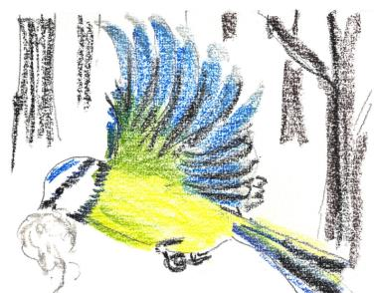

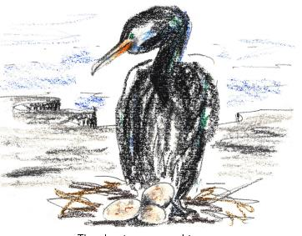

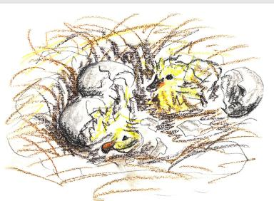

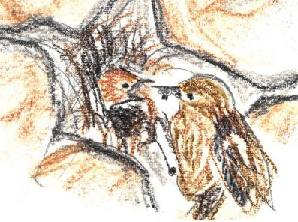

Guidance for writing – some dos and don’ts

- DO focus on letter formation. See sheet below. It’s really important that children get into the habit of writing letters correctly – this is not about how the finished letter looks, it’s all about how they write it – what direction they move the pencil or pen. Bad habits are almost impossible to break – if they form letters wrongly, the finished letter may look good BUT in the long run, they are much less likely to be able to write fluently.

- DON’T write a word or a line for them to copy. If they can’t remember how to write a letter, demonstrate, forming it correctly, so that they can imitate you.

- DO give loads of praise. Writing is so hard, and children get discouraged easily. It may be that they have just written one or two words, but if you praise them, it may be four words next time!

- DON’T do ‘dotty’ letters for them to trace. It is much better for children to form their own letters. We are teaching them to write not trace!

- DO write for them sometimes. It is important that young children can express their ideas in written form, and sometimes it is really good to write down what they say so that their ideas are expressed in writing on the page. Sometimes you can take turns to scribe. You write a bit, then they write a bit.
