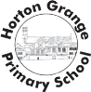
Horton Grange Primary School Year 5
Spring 2, 2018 - 2019
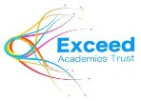
Teaching and Learning Information for Parents
Maths  This half term we will be looking at reflection and translation. Children will be working on developing their confidence in addition, subtraction, multiplication and division. They will also be focussing on developing their using and applying skills in the above areas.  It is important for children to be making a concerted effort to learn their multiplication tables to support them in their Maths lessons. |  |  | English  Our English topic will be to be able to explore persuasive texts linked to the Turtles. This links to our Blue Planet Aquarium visit next half term.
Science

This half term, in Science, we will be learning about Earth and Space. In the second week of the half term the children will be lucky enough to visit a planetarium where they will attend workshops all about the planets and astronauts. In this topic the children will learn about day and night, the movements of the Earth, Sun and Moon and will even find out more about being an astronaut!
History  In History this half term we will be looking at life in England during the Viking period. The children will look at various aspects of Viking life and compare these to what they already know about the Anglo-Saxons. The children will make use of historical artefacts to develop their historical enquiry skills. | Computing  In Computing children will be learning and applying data handling skills. The children will use spreadsheets to complete data related tasks. This will build on their current skills to increase their computer literacy. |  | Spring 2  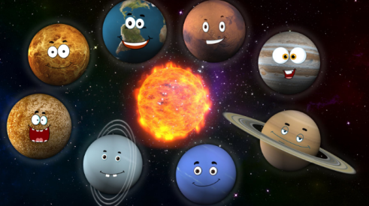  Thank you for your continued support! |  | MFL  In Arabic this term children will continue to revise vocabulary from last term. They will be learning the names of zoo animals and will be learning how to describe one of these animals by using the sentence opening ‘It has...’ They will also be using the key vocabulary they have learnt to hold short conversations. |  | PSHE  In PSHE our topic is ‘Health’. ‘Good to be me’ is our SEAL topic. Health will focus on children learning how to be healthy in all aspects of their lives. Children will consider their individual qualities. The two topics will help build self-esteem.
Physical Education  Children will be developing their dancing skills within Dance. This will include working on developing performance skills. Children will also be participating in the striking and fielding game of Cricket. |  | Music  In Music children will continue to learn about lyrics and melodies. They will continue to use their Ukuleles with our specialist music teacher. Children will be learning some songs which link to other areas of the curriculum. |  | Design Technology  Children will work with a variety of art and craft materials to create a space themed diorama. The children will work on designing, planning, making and evaluating their work. |  | Tutoring Club  English tutoring club will continue to run from 3:10 – 3.45p.m on a Wednesday.  Maths tutoring club will continue to run from 3:10 – 3.45p.m on a Tuesday.

