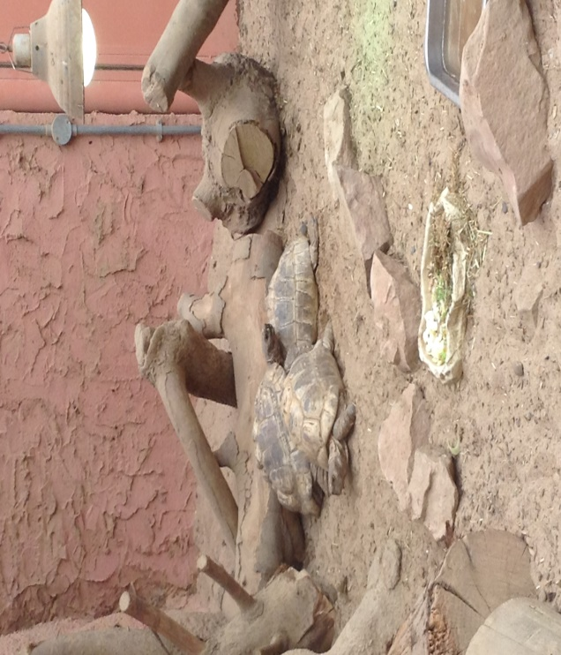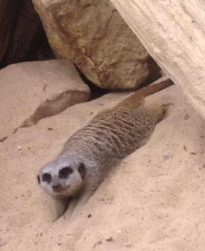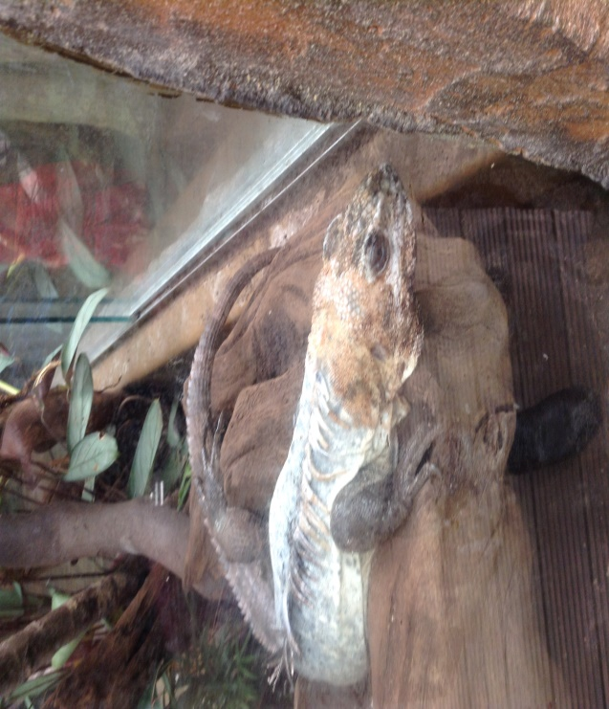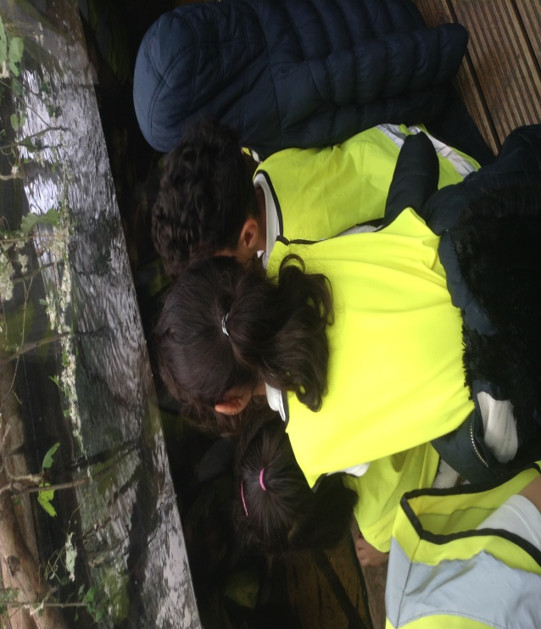

Our Visit to Tropical World!

During this summer term the children in Reception have been learning all about minibeasts. The children thoroughly enjoyed experiencing the different habitats that are available at Tropical World. We walked through the ‘Rainforest floor’, the ‘Rainforest Canopy’ and we even got to peek into the world of nocturnal creatures. RB really enjoyed looking at some cuddly looking Meer cats being their cute little selves and laughed at the antics of the Owl Monkeys. However, as we have been reading the story of, ‘The very hungry caterpillar’, we were so surprised to learn that Tropical World has free roaming butterflies and a variety of cocoons for everyone to see.