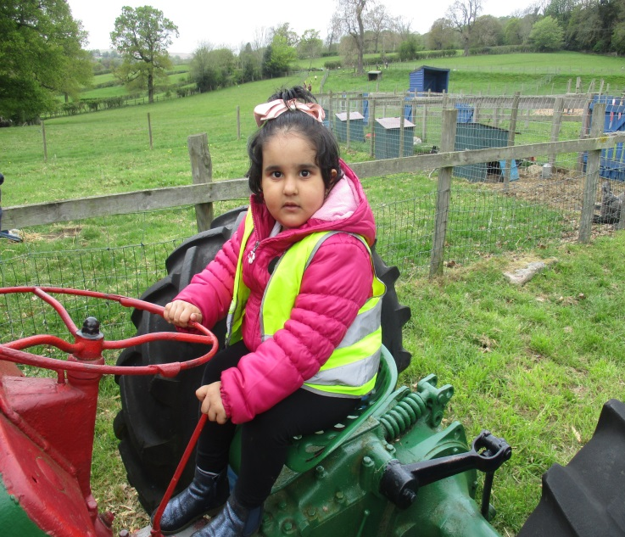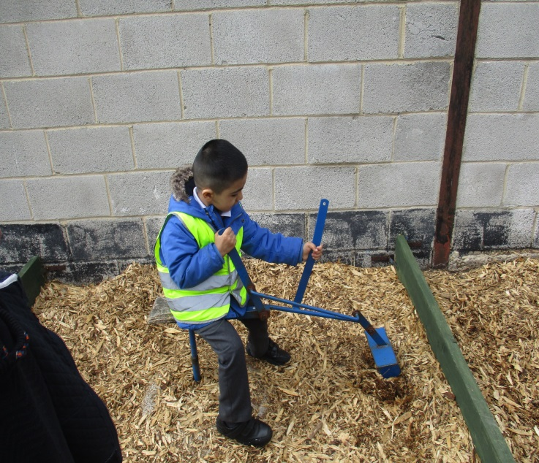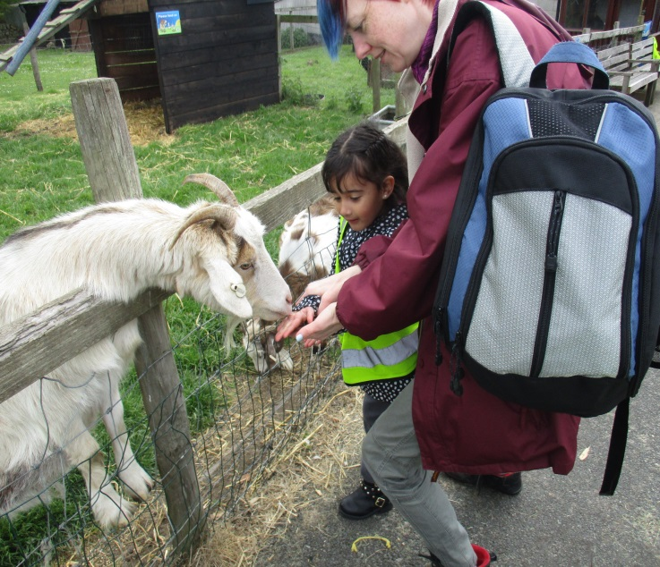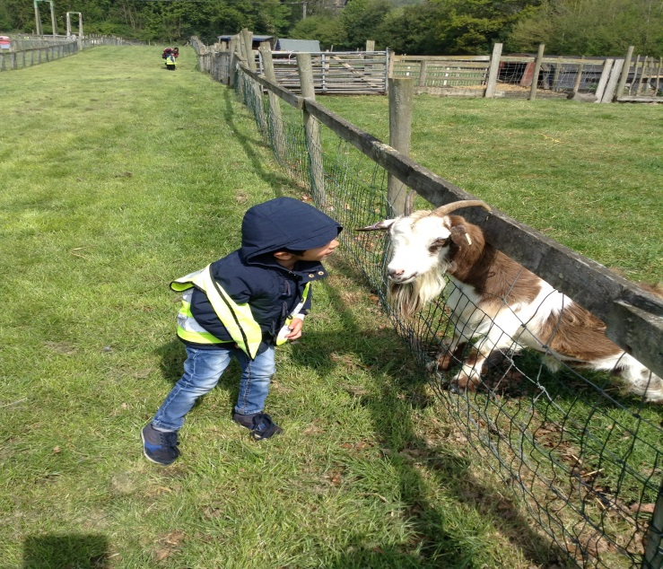

The Nursery children visited St. Leonard’s Farm to help them with their Farm animal topic. They were so excited to meet all the animals. They had the opportunity to stroke the baby goats and lambs as well as lots of other animals. The children were very brave and fed the donkeys, goats and sheep by hand. The goats were very friendly and very greedy! They even scattered some food for the chickens. In the afternoon they played in the Fun Barn and had lots of fun on the big slides. We were lucky enough to see some baby goats only a few minutes after they had been born.

What a fantastic day!

Nursery Farm Visit