
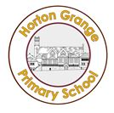
Year 6 Newsletter
Autumn 2nd half-term 2018

Our newsletters will give you a snapshot of the work, events and important information you need to be aware of over the coming weeks at school.

This second half-term brings the Year 6 residential visit to London!!! This visit is going to bring learning to life for the children who are attending. For those who are not going on the residential, we will be bringing London to them via a series of lessons around iconic London buildings and events. During this term we will be focussing on Settlements in Geography, learning about trade links in and out London. We will be reading poetry in English and using this as the inspiration for a lot of our writing for the second half- term. As part of our D.T project, we will be planning and developing a 3D sculpture.
In Science we will be investigating evolution and inheritance. We will look at features that have been passed on from parents to offspring and how animals and humans have evolved over time.
In R.E, we will be learning the different beliefs about God. P.S.H.E will be linked to the Economy and P.E will focus on Gymnastics and Football, while Music will be linked to exploring musical processes. In MFL, the children will continue to develop their spoken and written Arabic.

Educational Visits
The residential visit to London takes place on Thursday 8th November 2018 and we will return to school on Friday 9th November 2018. The staff taking the children on this visit will be Mrs Stephenson, Mrs Naylor and Mr Ahmed.

The children are already extremely excited about this wonderful opportunity and the experiences that they will encounter.

If you still have a balance outstanding for this visit, you can pay via ParentPay.

Letters with more details to follow…

Homework/Home-learning
English and Maths homework is handed out on Wednesday and must be handed in the following Monday. We cannot stress how important it is that children complete their homework to a high standard. This will be monitored throughout the year.

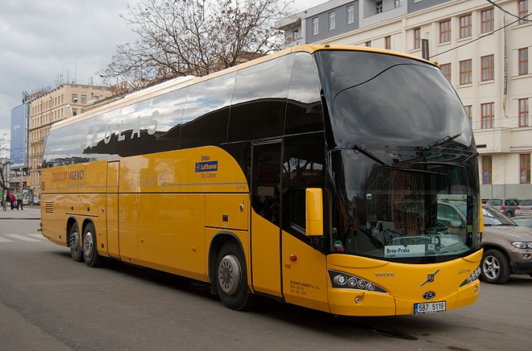

Helping with Core Subjects:
English: your continued support at home with helping your child to read is vital in enabling them to do their best. A minimum of 10 minutes per night of reading to you can yield huge benefits. Please comment in the Raving Readers record book and be sure to say if they have completed their reading book at home, so that they can change the book in school. Children must access Bug Club, at least once a week. If your child is unable to access the internet at home, please speak to the class teacher.

Maths: continuously learning and practising times tables is invaluable, therefore please encourage your child to continue to do so at home. Weekly homework revises and reinforces skills taught during lessons.
Year 6 Staff

Class Teachers:
6A: Miss Nore
6B: Mr Ahmed
6C: Mrs R. Ahmed

Year 6 Teaching Team:
Mrs. Naylor

PPA:
Mrs N Ahmed, Mrs L Salthouse and Miss T Ackernley

Year 6 Support:

Mrs Kauser
Miss Kauser

Please Note!
Planners: Please remember to sign your child’s Planner after every school week.
Raving Readers is now to be recorded in your child’s planner. This must be signed daily to show that you have listened to your child read daily. Your child will receive a mark on the class chart to indicate their progress. To acknowledge and celebrate those children who read at home, they will receive prizes for their efforts.

SETS
The structure of sets in Year 6 this year is as follows:
There are four sets for English and Maths (some sets are equal ability; they are not simply top to bottom). We have used the results of the children’s assessments from Year 5 to group them. As always, the make- up of sets is flexible, so children may move between teaching groups during the year, according to their progress and attainment. This enables us to better cater for their individualised learning needs as they move towards SATs.

Year 6 Key Dates
London Visit: 8th and 9th November 2018

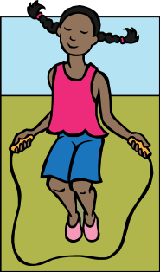
Year 6 P.E. lessons are on Wednesday and Friday.
By law, your child must take part, so make sure they have their kit or they will have to use a shared one! Children will only be excused from a P.E. lesson if we receive a letter from parents (a note in the Planner is okay) explaining the medical reason why they can’t join in each lesson they will miss. We’ve found it useful if the children leave their P.E kits on Wednesday, ready to use on Friday. They can then take them home to wash at the end of the week.

